Brazilian Fruit
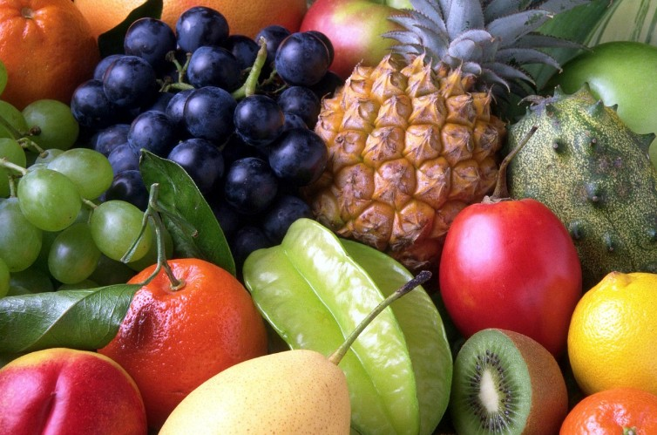

Fruit takes a central role in Brazilian daily cuisine, and can be served at breakfast, for a snack, and as dessert after lunch or dinner. Brazilian fruits are delicious and highly nutritious. Brazil is a tropical country but has many different types of land and climates, resulting in a wide range of fruit. There are fruits that are always available, like mangoes, papayas and bananas. There are also less common fruits that are seasonal or regional, like jabuticaba and atemoia. Did you know that there are approximately 3,000 types of fruit that grow in the Amazon?!

When fruit is not ready, it’s called verde, which means "green". When you buy fruit at a supermarket, you sometimes have to weigh it in the produce section before going to the cashier. You generally buy fruit por kilo which means "by the kilo".

Here are some fruits which have English names:

Apple (maçã) Lime (limão)
Avocado (abacate) Mandarin (mexerica)
Banana (banana) Mango (manga)
Blackberry (amora) Orange (laranja)
Cacao (cacau) Papaya (mamão)
Persimmon (caqui) Passion fruit (maracujá)
Cashew (caju) Pineapple (abacaxi)
Coconut (coco) Plum (ameixa)
Guava (goiaba) Star fruit (carambola)
Jackfruit (jaca) Sugar apple (pinha/fruta do conde)
Lemon (limão siciliano) Watermelon (melancia)

Here are some fruits which are not well-known in the UK:

Acaí Jabuticaba
Acerola Mangostin
Atemoia Pitaia
Cajá Pitanga
Cupuaçu Rambutan (similar to lychee / lichia)
Graviola Sapoti
Guaraná Tamarindo

Some interesting facts:

- Acerola has 100 times more vitamin C than oranges. Acerola juice is excellent to help avoid colds and the flu.

- Guaraná is an effective stimulant because it contains about twice the quantity of caffeine than that of coffee beans. It can also improve memory.

- Acaí is rich in a number of vitamins and athletes use it as a quick source of energy. It has many health benefits and is used in juices, smoothies, drinks, powders, supplements, energy drinks and weight loss products.

- A jackfruit can weigh up to 40 kilograms.

Source: https://thisismyhappiness.com/fruit-in-brazil/

